
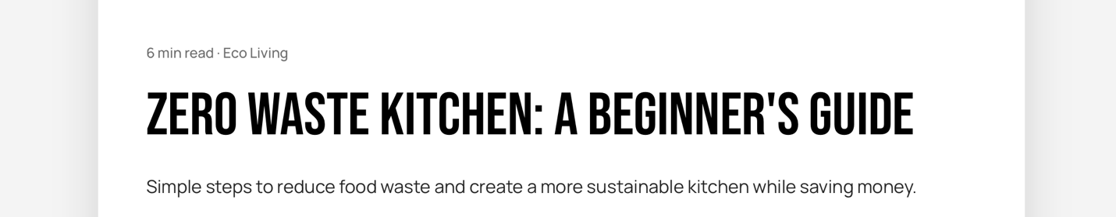
Something to Chew On | Trivia Before you read on, let’s test your Food IQ!

You're about to bake, but you notice the expiration date on your carton of eggs passed yesterday. What is the easiest, zero-waste way to test if an egg is still perfectly safe to eat without cracking it open?

A) Shake it next to your ear to listen for a slishing sound.
B) Drop it in a glass of water to see if it sinks or floats.
C) Hold it up to a bright flashlight to see through the shell.
D) Roll it on the counter to see how fast it spins.
Answer displayed at the end of the article


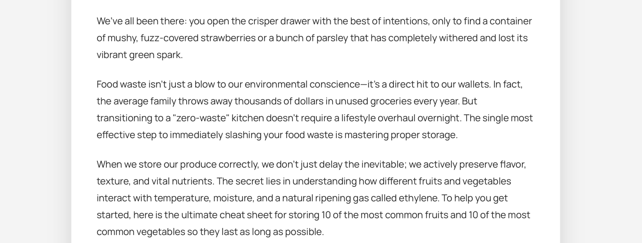
[Insert Chart]
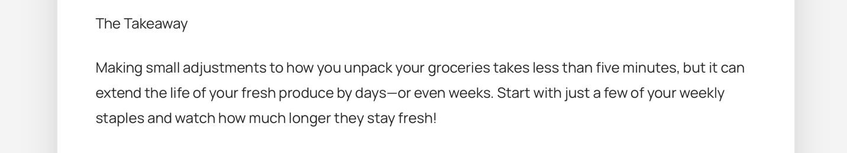
Trivia Answer Reveal
The answer is B — Did you guess correctly?

This is known as the "Float Test!" Bad eggs accumulate air inside the shell over time. Expiration dates are often just estimates, this quick trick keeps you from accidentally wasting perfectly good eggs!

If it sinks to the bottom and lays flat on its side: It’s super fresh.
If it stands upright on the bottom: It’s older, but still perfectly safe to cook (and bonus: these make the absolute easiest-to-peel hard-boiled eggs!).
If it floats to the top: It’s time to toss it.



